- List all the main components you find inside a desktop PC after opening the Cabinet and write a short description (1-2 lines) for each.
Answer :-
Main Components Inside a Desktop PC
Components | Description
Motherboard | The main circuit board that connects and allows communication between all computer components.
CPU (Central Processing Unit) | The brain of the computer that processes instructions and performs calculations.
CPU Cooler (Fan & Heatsink) | Keeps the CPU cool by dissipating the heat generated during operation.
RAM (Random Access Memory) | Temporary memory used to store data and programs that are currently in use.
Graphics Card (GPU) | Processes graphics and video, providing smooth gaming, video editing, and display performance.
Storage Drive (HDD/SSD) | Stores the operating system, software, and user files permanently.
Power Supply Unit (PSU) | Converts AC power from the wall outlet into DC power for all internal components.
Case Fans | Improve airflow inside the cabinet to keep the system cool.
Expansion Cards (PCIe Cards) | Additional cards such as Wi-Fi, sound, or capture cards that extend the computer's functionality.
SATA/Data Cables | Connect storage devices like HDDs and SSDs to the motherboard for data transfer.
Power Cables | Deliver power from the PSU to the motherboard, storage drives, GPU, and other components.
CMOS Battery | Maintains BIOS/UEFI settings and keeps the system clock running when the computer is powered off.

- Take clear photos or draw labeled diagrams of each step as you disassemble a desktop PC and organize them in a document with captions explaining what you did at each step. Include steps like unplugging power, removing side panel, disconnecting cables, and removing RAM, HDD/SSD, and motherboard.
Answer :-

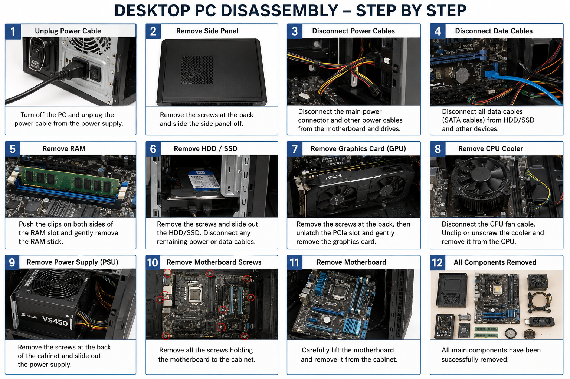

- Reassemble the PC you disassembled, documenting each step with a brief explanation of what you connected or installed and why the order matters.
Answer :-
Reassembling a Desktop PC
Step 1: Install the Motherboard :-
- Carefully place the motherboard inside the cabinet and align it with the mounting holes.
- Secure it using screws.
- Why this step comes first: The motherboard is the main component to which all other hardware is connected.
Step 2: Install the CPU :-
- Gently place the CPU into the CPU socket, matching the alignment mark.
- Lock the CPU in place using the socket lever.
- Why this step matters: The CPU must be installed before attaching the CPU cooler.
Step 3: Install the CPU Cooler :-
- Apply thermal paste if required.
- Mount the heatsink and fan securely.
- Connect the CPU fan cable to the CPU_FAN header on the motherboard.
- Why this step matters: The CPU requires proper cooling before the computer is powered on.
Step 4: Install the RAM :-
- Align the notch on the RAM module with the memory slot.
- Press firmly until both retaining clips lock into place.
- Why this step matters: RAM is required for the computer to boot and run applications.

Step 5: Install the Storage Drive (HDD/SSD) :-
- Place the HDD or SSD into its drive bay.
- Secure it with screws or the mounting bracket.
- Connect the SATA data cable to the motherboard and the SATA power cable from the PSU.
- Why this step matters: Storage is needed for the operating system and files.
Step 6: Install the Graphics Card (GPU) :-
- Insert the GPU into the PCIe x16 slot.
- Tighten the mounting screw.
- Connect the PCIe power cable if required.
- Why this step matters: The graphics card provides display output and improves gaming performance.
Step 7: Connect Power Supply (PSU) :-
- Connect the 24-pin ATX power cable to the motherboard.
- Connect the 8-pin CPU power cable.
- Connect power cables to the GPU, HDD/SSD, and other devices.
- Why this step matters: Every component requires power from the PSU to function properly.
Step 8: Connect Front Panel and Other Cables :-
- Connect the Power Switch, Reset Switch, Power LED, HDD LED, USB, and Audio cables.
- Organize the cables neatly for better airflow.
- Why this step matters: These connections allow the computer's front buttons and ports to work correctly.
Step 9: Close the Cabinet :-
- Reattach the side panel.
- Tighten the screws securely.
- Why this step matters: It protects the internal components and improves airflow inside the cabinet.

Step 10: Power On and Verify :-
- Connect the power cable, monitor, keyboard, and mouse.
- Turn on the PC.
- Check that the system boots successfully and all components are detected.
- Why this step matters: This confirms that all hardware has been installed and connected correctly.

- Create a checklist of safety precautions and tools needed before starting the PC assembly/disassembly process and explain why each is important.
Answer :-
Checklist of Safety Precautions
Safety Precaution | Why It Is Important
Turn off the computer completely | Prevents electrical hazards and protects the hardware from damage.
Unplug the power cable | Eliminates the risk of electric shock while working inside the PC.
Press the power button for 5–10 seconds after unplugging | Discharges any remaining electrical power stored in the system.
Wear an anti-static wrist strap (or touch a grounded metal object) | Prevents electrostatic discharge (ESD), which can damage sensitive components.
Work on a clean, dry, and flat surface | Reduces the risk of losing screws or damaging components.
Handle components by the edges | Avoids touching sensitive chips and electrical contacts.
Keep food and liquids away from the work area | Prevents accidental spills that could damage electronic components.
Store screws in a small container | Prevents screws from getting lost during assembly or disassembly.

Tools Required
Tool | Why It Is Important
Phillips Screwdriver | Used to remove and tighten screws on the cabinet and internal components.
Anti-Static Wrist Strap | Protects computer components from electrostatic discharge (ESD).
Plastic Cable Ties | Helps organize cables for better airflow and easier maintenance.
Small Container or Magnetic Tray | Keeps screws and small parts safe and organized.
Soft Cleaning Brush or Compressed Air | Removes dust from components without causing damage.
Flashlight (Optional) | Helps clearly see connectors and screws inside the PC cabinet.

